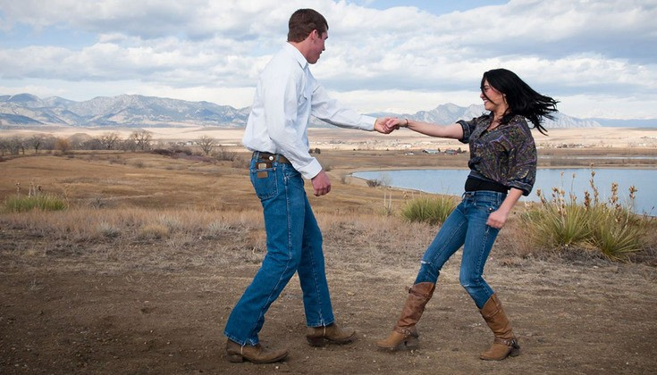

P A L M E R L A K E F U N R A I S E R S I N V I T E Y O U

COUNTRY TWO-STEP

DANCE LESSON
MARCH 20 TH 6 - 7 LESSON OPEN PRACTICE 7 : 00 - 7 : 30
ONLY 1 SPOT LEFT!
$26 per couple for 1hr lesson and practice
email Laurie:
festivalonthefourth@ gmail. com to reserve your place
Next lesson Monday March 27 th space is l imited
Palmer Lake Town hall
46 Valley Cresent, Palmer Lake.

